Analyzing Advertising Expenditure
John Wensink
MTH122-1
Colorado State University-Global Campus
Mirela Negoita
August 2, 2020

Analyzing Advertising Expenditure
“As a data scientist of a company, you want to analyze the following data collected by your company which relates the advertising expenditure A in thousands of dollars to total sales S in thousands of dollars. The following table shows this relationship” (CSU-Global, n.d.)
Sales as a Function of Advertising Expenditure?
Advertising Expenditure (A) | Total Sales (S)
18.6 | 312
18.8 | 322
18.8 | 333
18.8 | 317
19 | 301
19 | 320
19.2 | 305

From the data depicted above, we can see that the relationship between Advertising expenditure and Sales is not a function, as there are multiple instances of Advertising Expenditure = 18.8, and 19 that do not correspond to the same value of total sales. The relationship, therefore, is not a function.

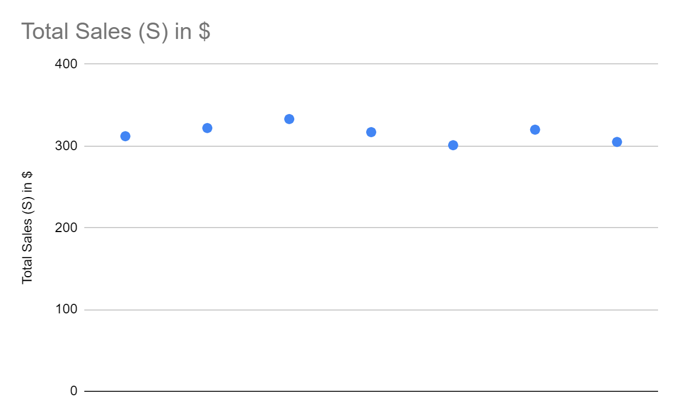
Creating a scatter plot, we can see graphically that this chart clearly does not pass the ‘horizontal line test’ (CSU-Global, n.d.). We can also use excel to do some basic linear regression on the data we have, adding a simple best-fit curve to the scatter plot.
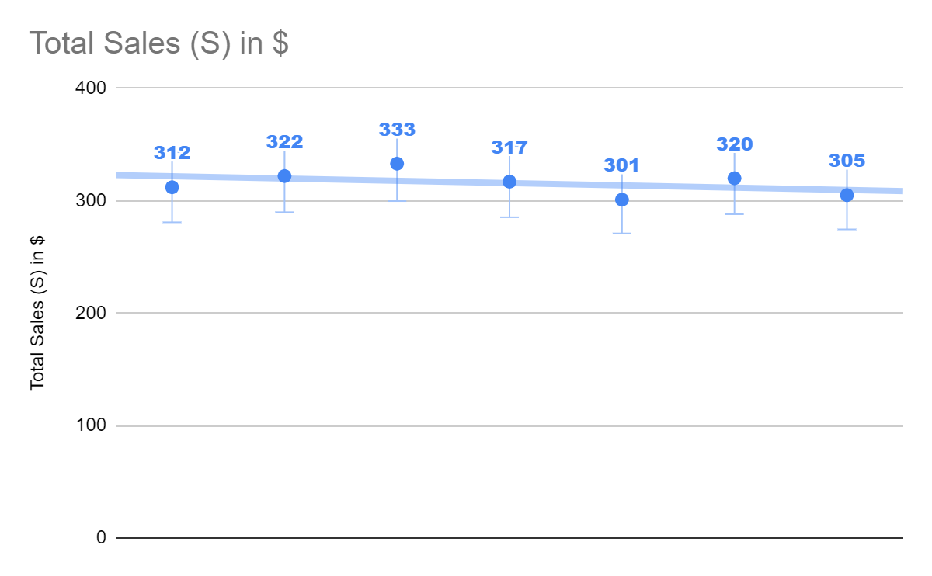

Interpret the Slope and y-Intercept
Using the following table to keep track of our X, Y, XY, X²,Y² values

X | Y | XY | X^2 | Y^2
18.6 | 312 | 5803.2 | 345.96 | 97344
18.8 | 322 | 6053.6 | 353.44 | 103684
18.8 | 333 | 6260.4 | 353.44 | 110889
18.8 | 317 | 5959.6 | 353.44 | 100489
19 | 301 | 5719 | 361 | 90601
19 | 320 | 6080 | 361 | 102400
19.2 | 305 | 5856 | 368.64 | 93025

we are able to use the equation m=(y₂-y₁)/(x₂/x₁) or 10/0.2, or m=50. Now that we have the slope of the line we can calculate the y-intercept using the equation y=mx+b. We will find the y-intercept, by using the equation y=50x+b, or 312=50(18.6)+b, or 312=930+b, subtracting 930 from both sides we find b=-618 (Imson, n.d.). Alternatively, we could write this equation as a function S of A. y will be substituted for the function f(x). So, f(x)=50x-618 would be this line expressed in function notation. Using this notation, if we input 24000 as our advertising expenditure we can see that y or total sales = F(x)=24,000(50)-618 or 1,200,000-618= 1,199,382. Let’s hope that this process continues to scale linearly!
Conclusion
From this example, we were able to determine that this relationship is not a function of advertising dollars spent, as there were multiple instances of the same amount of money being spent, with different amounts of money being taken in. We were able to calculate the slope of our line and extrapolate it out to the millions of dollars in revenue. This was able to be calculated by using slope-intercept notation as a function of advertising dollars spent. With a slope of 50, it is easy to see how we can start to get into serious profits based on advertising dollars spent, unfortunately it is unlikely that this trend will continue, as the relationship we are exploring is not a function.

References
Grace Imson, M. (2020, June 15). How to Find the Y Intercept. Retrieved August 03, 2020, from https://www.wikihow.com/Find-the-Y-Intercept

